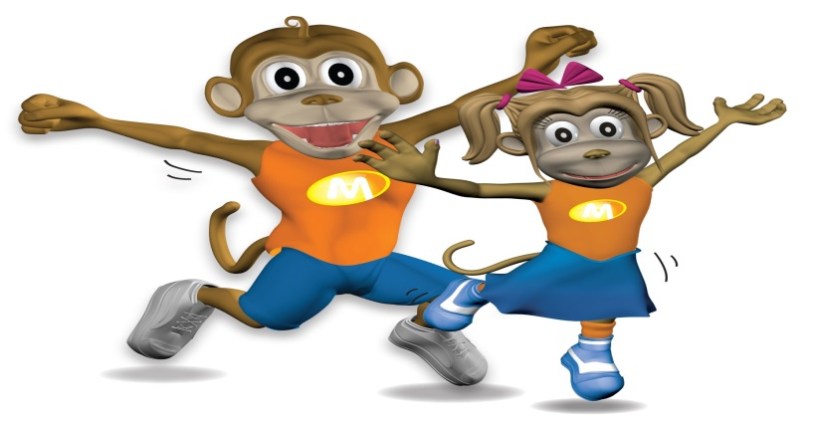

*CALL:* ***905-407-0016***

*Email:*

[***christo@monkeynastix.ca***](mailto:christo@monkeynastix.ca) ***info@rhythmdance.com***

A **FUN, HOLLISTIC, and CHALLENGING fitness movement education program for children to develop a positive self-image, strength, agility, balance and co-ordination.**

**“The ABC’s of Physical Literacy.”**

**Ages 1- 8 / $160 + HST – 8 week session**

FREE DEMO

**FREE DEMO**

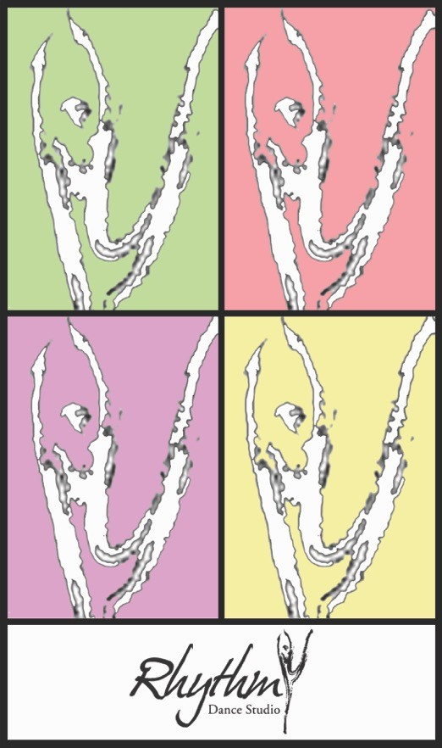 **Sunday 1 May 2016**

**Times for Demo**

**Age 1 to 2** years old / 10; 00 to 10; 30 am (parent participation)

**Age 3 to 5** / 10:45 to 11:15 am

**Age 6 to 8** / 11:30 to 12 noon

**TO REGISTER FOR FREE DEMO CLASS!!**

Limited space, book now

